MANGOCHI CATHOLIC DIOCESE MOCK EXAMINATIONS
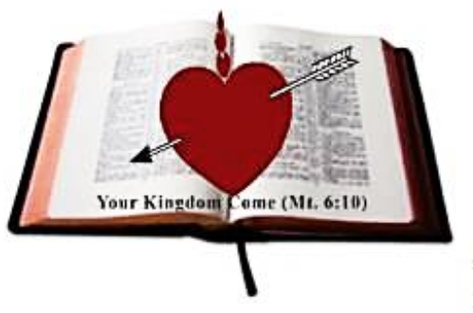
2025 MALAWI SCHOOL CERTIFICATE OF EDUCATION
CHEMISTRY
Thursday, 22 May 2025 Subject Number: M038/I
Time Allowed: 2 hours
8:00 - 10:00 am
Question Number | Tick if answered |  | Do not write in these columns
1
2
3
4
5
6
7
8
9
10
11
12
13
 |  | Total
PAPER I
(40 marks)
Instructions:
- This paper contains 13 printed pages. Please check.
- There are two sections in this paper; A and B.
- Answer all questions in all sections.
- Write your Examination Number on top of each page of your question paper.
- In the table provided on this page, tick against the question number you have answered.

© 2025 MH DIOCESE Turn Over
Section A (70 marks)
Answer all the ten questions in this section in the spaces provided.
- a. What is the difference between isomers and conformers?
_______________________________________________________________________________
_______________________________________________________________________________
_______________________________________________________________________________
(2 marks)
b. Figure 1 below shows different structures of an organic compound.

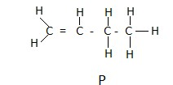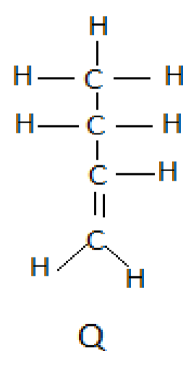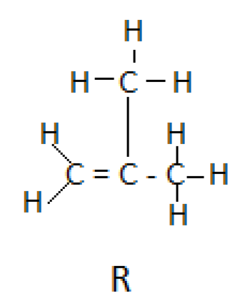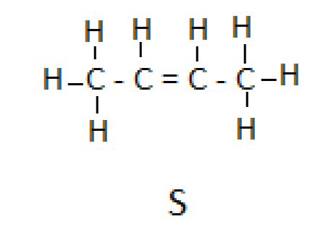 Figure 1

- Which two structures are conformations of each other?

_________________________________________________________________________
(1 mark)
ii. Which of the structures has the lowest boiling point?
_________________________________________________________________________
(1 mark)
iii. Give a reason for your answer in 2b (ii).
_________________________________________________________________________
_________________________________________________________________ (2 marks)
- a. State any two conditions that are necessary for rusting to take place.
_______________________________________________________________________________
_______________________________________________________________________________ (2 marks)
continued/…
b. Figure 2 is a diagram showing the process of electroplating a carbon rod.
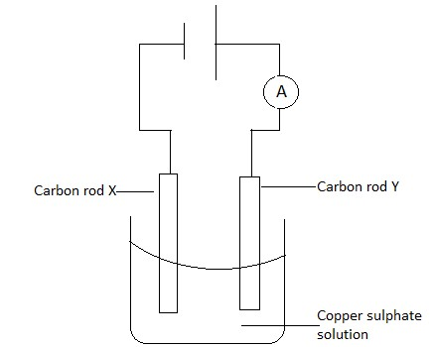
Figure 2
i. Which carbon rod would be electroplated?
_______________________________________________________________________
(1 mark)
ii. Write down a half equation for the reaction at carbon X.
_______________________________________________________________________
(1 mark)
iii. State any two observations that would be made in the experiment after some time.
_______________________________________________________________________
_______________________________________________________________________
(2 marks)
- a. Define the term ‘empirical formula’ of a compound.
_______________________________________________________________________________
_______________________________________________________________________________
(1 mark)
  - Find the molecular formula of a compound with the empirical formula CH₂ O and a molecular weight of 60 g/mol. (RAM of C = 12, H = 1 and O =16) (3 marks)

continued/…
  - A chemist carries out a reaction to produce 25.0 g of aspirin. The theoretical yield of aspirin is 30.0 g. Calculate the percentage yield of aspirin.

(3

marks)

- a. State any two effects of hydrogen bonding on physical properties of water.
_______________________________________________________________________________
_______________________________________________________________________________ (2 marks)
  - Equal number of drops of soap solution was added into four test tubes of equal amount of water taken from different sources. After shaking, the heights of lather were obtained as shown below in figure 3.
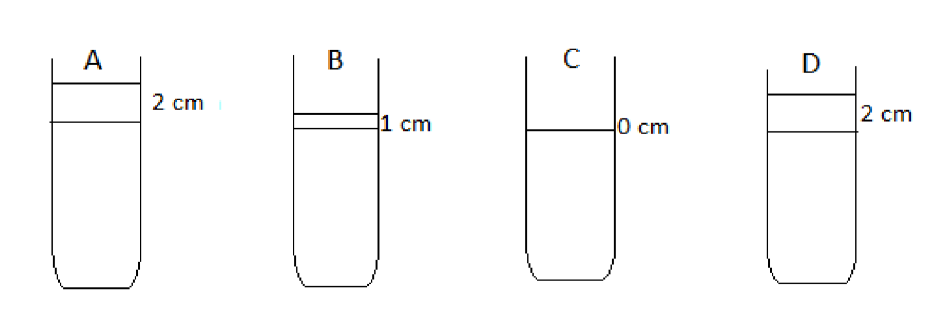
i. Which two water samples were taken from the area of the same water hardness?
_________________________________________________________________________
(1 mark)
ii. Identify the hardest water.
_________________________________________________________________________
(1 mark)
continued/…
iii. Give a reason for your answer in 4b (ii).
_________________________________________________________________________
_________________________________________________________________________
(1 mark)
c. State any two chemical methods of removing water hardness.
__________________________________________________________________________________
__________________________________________________________________________________
(2 marks)
5. a. What is an electrode potential?
_______________________________________________________________________________
_______________________________________________________________________________ (1 mark)
b. Calculate the standard electromotive force (e. m. f) of
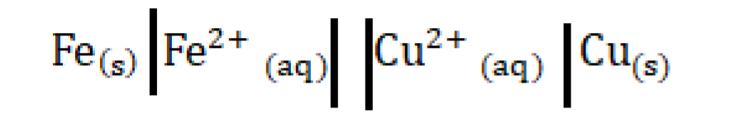
Given that:
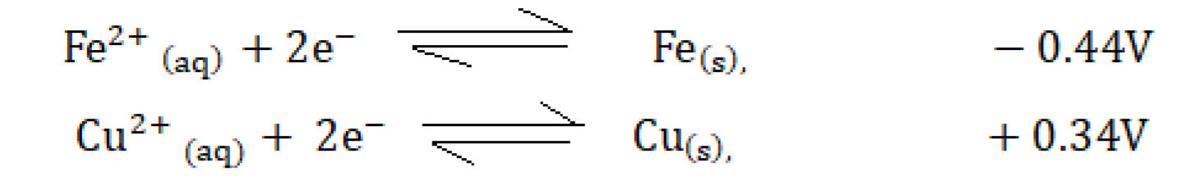

(3

marks)

- a. Mention two types of polymers.
_______________________________________________________________________________
_______________________________________________________________________________
(2 marks)
continued/…
  - Figure 4 below shows the types of plastics. Use it to answer the questions that follow:
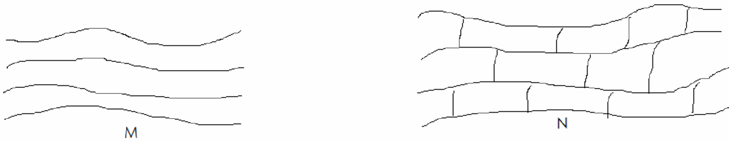
i. Name the type of plastic represented by M.
_______________________________________________________________________
      - mark)
ii. State any two properties of plastic N.
_______________________________________________________________________
_______________________________________________________________________
_______________________________________________________________________
      - marks)
- a. State any two methods of disposing laboratory chemical wastes.
_______________________________________________________________________________
_______________________________________________________________________________
(2 marks)
  - Figure 5 below shows graphs of melting of two substances, A and B. Use them to answer the questions that follow.
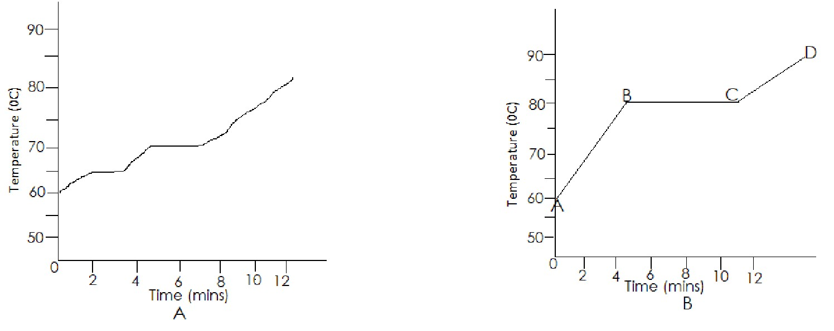
i. Identify the graph that is represented by a mixture.
____________________________________________________________________
(1 mark)
continued/…
ii. Give a reason for your answer in 7b (i).
____________________________________________________________________
(1 mark)
- State any two uses of phosphorus.
__________________________________________________________________________ __________________________________________________________________________
(2 marks)
- Figure 6 below shows the two allotropes of carbon. Use them to answer the questions that follow.
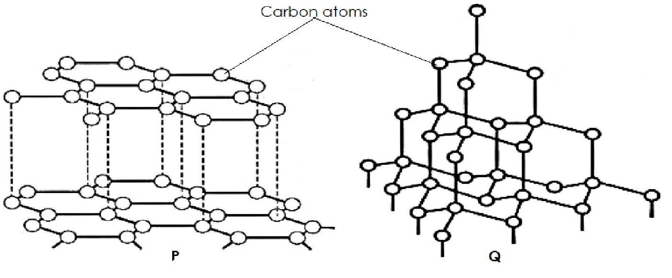
Figure 6
i. Name allotrope P.
__________________________________________________________________________
  - mark)
ii. State one difference of physical property between P and Q.
__________________________________________________________________________
__________________________________________________________________________
(1 mark)
iii. State one use of allotrope Q.
__________________________________________________________________________
(1 mark)
iv. Which allotrope conducts electricity? __________________________________________________________________________
(1 mark)
v. Give a reason for your answer in 7d (iv).
__________________________________________________________________________
__________________________________________________________________________
  - marks)
continued/…
8. Hydrogen burns in air to form steam according to the equation:
2H₂ _{(g )} + O₂ _{(g )} → 2H₂ O _{(g )}
- Which bonds are broken?
____________________________________________________________________________
(1 mark)
- Calculate ∆H for the reaction given the bond energies as:
Bond | Energy (KJ/mol)
H-H | 436
O=O | 498
O-H | 463

(4 marks)

- Name the type of reaction basing on the calculation above.
____________________________________________________________________________
(1 mark)
9. a. Define a ‘base’ according to Bronsted-Lowry theory.
_______________________________________________________________________________
(1 mark)

continued/…
b. Describe how a hydronium ion (H₃ O⁺) is formed.
_______________________________________________________________________________
_______________________________________________________________________________
_______________________________________________________________________________
(2 marks)
c. (i) Define the term “precipitation”.
____________________________________________________________________________
____________________________________________________________________________
(1 mark)
(ii) Silver nitrate solution is mixed with sodium chloride solution to form a precipitate according to the equation:
AgNO₃ _{(aq )} + NaCl_{( aq)} → AgCl_{( s)} + NaNO _{( aq)}.
Write the ionic equation for the chemical reaction above.

(2 marks)
d. Mention any two environments where the pH is regulated.
__________________________________________________________________________________
__________________________________________________________________________ (2 marks)
10. a. What is a catalyst?
_______________________________________________________________________________
_______________________________________________________________________________
(1 mark)
- How does the catalyst affect the rate of chemical reaction?
_______________________________________________________________________________
_______________________________________________________________________________
  - mark)

Continued/…
- Copper (II) oxide catalyzes the decomposition of hydrogen peroxide. 0.5 g of the oxide was added to a flask containing 100 cm3 of hydrogen peroxide solution. A gas was released. It was collected, and its volume noted every 10 seconds. The table below shows the results:
Time (seconds) | 0 | 10 | 20 | 30 | 40 | 50 | 60 | 70 | 80 | 90
Volume (cm3) | 0 | 15 | 30 | 40 | 45 | 55 | 60 | 65 | 65 | 65

i. Identify the method of measuring rate of chemical reaction used above.
________________________________________________________________________________
  - mark)
ii. Name the gas that was formed.
________________________________________________________________________________
(1 mark)
iii. Plot a graph of volume of gas against time.
(4 marks)
continued/…
Section B (30 marks)
Answer all the questions in this section in the spaces provided.

11. a. Describe an experiment that can be carried out to test for chlorine gas using blue litmus paper.
_______________________________________________________________________________
_______________________________________________________________________________
_______________________________________________________________________________
_______________________________________________________________________________
_______________________________________________________________________________
_______________________________________________________________________________
_______________________________________________________________________________
_______________________________________________________________________________
(4 marks)
b. Describe how salt is prepared using precipitation method.
_______________________________________________________________________________
_______________________________________________________________________________
_______________________________________________________________________________
_______________________________________________________________________________
_______________________________________________________________________________
_______________________________________________________________________________
_______________________________________________________________________________
_______________________________________________________________________________
_______________________________________________________________________________
_______________________________________________________________________________
_______________________________________________________________________________
_______________________________________________________________________________
_______________________________________________________________________________
_______________________________________________________________________________
_______________________________________________________________________________
_______________________________________________________________________ (6 marks)
continued/…

12. With the aid of a well labeled diagram, describe how ethanol could be prepared in the laboratory.

_______________________________________________________________________________
_______________________________________________________________________________
_______________________________________________________________________________
_______________________________________________________________________________
_______________________________________________________________________________
_______________________________________________________________________________
_______________________________________________________________________________
_______________________________________________________________________________
_______________________________________________________________________________
_______________________________________________________________________________
_______________________________________________________________________________
_______________________________________________________________________________
_______________________________________________________________________________
_______________________________________________________________________________
_______________________________________________________________________________
_______________________________________________________________________________
_______________________________________________________________________________
_______________________________________________________________________________
_______________________________________________________________________________
_______________________________________________________________________________
(10 marks)
continued/…

13. Describe how 500 cm3 of 0.1 M nitric acid solution could be prepared from nitric acid. Your explanation should include all necessary mathematical calculations.
_______________________________________________________________________________
_______________________________________________________________________________
_______________________________________________________________________________
_______________________________________________________________________________
_______________________________________________________________________________
_______________________________________________________________________________
_______________________________________________________________________________
_______________________________________________________________________________
_______________________________________________________________________________
_______________________________________________________________________________
_______________________________________________________________________________
_______________________________________________________________________________
_______________________________________________________________________________
_______________________________________________________________________________
_______________________________________________________________________________
_______________________________________________________________________________
_______________________________________________________________________________
_______________________________________________________________________________
_______________________________________________________________________________
_______________________________________________________________________________
_______________________________________________________________________________
_______________________________________________________________________________
_______________________________________________________________________________
_______________________________________________________________________________
_______________________________________________________________________________
_______________________________________________________________________________

(10 marks)
END OF QUESTION PAPER NB:
This paper contains 13 printed pages.

